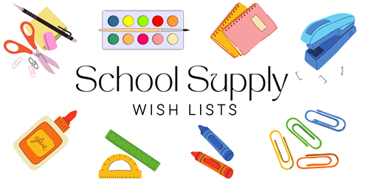

**2ND GRADE – DUAL LANGUAGE ONLY**

**24/25**

**PERSONAL ITEMS:**

2 LANYARDS WITH CLEAR BADGE ID HOLDER (HEAVY DUTY)

1 PENCIL POUCH

1 PAIR OF OVER THE HEAD HEADPHONES (NO EARBUDS)

8 MEAD MARBLE COMPOSITION NOTEBOOKS (100ct)

5 PLASTIC POCKET & BRAD FOLDERS (2 GREEN, 2 RED & 1 YELLOW)

1 BINDER 1.5”

**CLASSROOM ITEMS:**

2 REAMS OF COPY PAPER

4 PACKS OF 5 ELMERS CLUE STICKS (LARGE)

1 PACK CRAYOLA CRAYONS (24ct)

2 PAIRS FISKARS 5” SCISSORS – BLUNT TIP

2 HIGHLIGHTERS

2 PURPLE PENS

48 #2 TICONDEROGA PENCILS SHARPENED

1 PACKAGE BABY WIPES

1 PACKAGE OF DISINFECTANT WIPES

1 BOTTLE OF HAND SANITIZER

**BOYS ONLY:**

1 BOX OF BINDER CLIPS (MEDIUM)

1 BOX GALLON SIZE ZIPLOC BAGS

1 PACK BLACK EXPO LOW ODOR CHISEL DRY ERASE MARKER

1 SHARPIE FINE TIP BLACK MARKER

**GIRLS ONLY:**

1 PACKAGE MAGIC ERASERS (2 PACK)

1 BOX QUART SIZE ZIPLOC BAGS

1 PACK EXPO MARKERS (ASSORTED COLORS)

1 BLACK REGULAR SHARPIE